Thesis Evaluation Report: Multi Asset Return Prediction Benchmark
Protocol: v1_thesis_core Test window: 2020-01-02 to 2024-12-27
This report summarizes tuned experiments across XGBoost, LSTM and graph neural network variants. It reports predictive metrics and portfolio backtests under two rebalancing schedules (reb=1 and reb=5).

1. Experimental setup
Target: next day log return (regression), horizon=1.
Lookback window: 60 trading days for most models, 250 for Granger based graphs.
Splits: train up to 2015-12-31, validation 2016-01-01 to 2019-12-31, test from 2020-01-02 to 2024-12-27.
Backtest: reb=1 approximates daily rebalancing, reb=5 approximates weekly rebalancing.
Baseline context: test rebased buy and hold reaches a final value of 5.049, corresponding to an annualized return of about 38.4% over the test window.

2. Model families and variants
- XGBoost (xgb_raw): tree boosting on raw tabular features, no graph.
- XGBoost with Node2Vec features (xgb_node2vec_corr): Node2Vec embeddings computed on a correlation graph, used as additional features.
- LSTM: sequence model using the lookback window as input.
- GCN and GAT: graph neural networks with different edge definitions: correlation, sector and Granger causality, plus a combined graph.
- TGCN static and TGAT static: temporal GNN architectures used with static graph labels in this benchmark.

3. Evaluation metrics
- Prediction RMSE and MAE on the test set.
- Mean Rank IC (Spearman rank correlation between predicted and realized returns in the cross section).
- Portfolio metrics from the backtest: annualized return, annualized volatility, annualized Sharpe, annualized Sortino, max drawdown and turnover.

4. Key findings
- Prediction errors are tightly clustered across models, indicating that point forecast accuracy is broadly similar.
- Ranking skill differs more than point error. xgb_node2vec_corr shows the highest mean Rank IC and is the most consistent top performer across settings.
- Weekly rebalancing (reb=5) improves Sharpe for all models and reduces turnover substantially relative to daily rebalancing (reb=1).
- All tested model driven portfolios underperform the test buy and hold baseline during 2020 to 2024. The best model reaches a final value of about 2.01 versus 5.05 for buy and hold (rebased).
- Several GNN variants indicate graph windows that extend into the test period while training ends in 2015. This must be verified as time aware graph construction to avoid lookahead leakage.

5. Comparative results

5.1 Top models by Sharpe, reb=5
Run | Model | Edges | Rank IC | Ann Return | Sharpe | Max DD | Turnover | Final
xgb_node2vec_corr_tuned_all | xgb_node2vec | node2vec_correlation | 0.016 | 15.2% | 0.806 | -32.8% | 13.6% | 2.011
xgb_raw_tuned_all | xgb_raw | none | 0.004 | 13.5% | 0.739 | -31.2% | 14.0% | 1.873
lstm_tuned_all | lstm | none | -0.001 | 14.0% | 0.714 | -34.7% | 12.9% | 1.901
gat_corr_sector_granger_tuned_all | gat | corr+sector+granger | -0.008 | 13.3% | 0.703 | -30.9% | 14.7% | 1.853
tgat_static_corr_only_tuned_all | tgat_static | corr | 0.004 | 13.9% | 0.692 | -34.5% | 12.5% | 1.901
gcn_sector_only_tuned_all | gcn | sector | 0.006 | 13.5% | 0.692 | -34.0% | 14.3% | 1.862
gat_sector_only_tuned_all | gat | sector | 0.003 | 13.0% | 0.670 | -31.8% | 14.4% | 1.818
gat_granger_only_tuned_all | gat | granger | -0.008 | 12.8% | 0.655 | -35.2% | 13.5% | 1.808
gcn_corr_only_tuned_all | gcn | corr | -0.002 | 11.0% | 0.629 | -30.6% | 13.6% | 1.673
tgcn_static_corr_only_tuned_all | tgcn_static | corr | -0.001 | 11.9% | 0.623 | -33.5% | 14.1% | 1.729

Best weekly run: xgb_node2vec_corr_tuned_all with Sharpe 0.806, mean Rank IC 0.016 and final value 2.011. This is 39.8% of the buy and hold final value.

5.2 Top models by Sharpe, reb=1
Run | Model | Edges | Rank IC | Ann Return | Sharpe | Max DD | Turnover | Final
xgb_node2vec_corr_tuned_all | xgb_node2vec | node2vec_correlation | 0.016 | 12.0% | 0.660 | -29.5% | 56.6% | 1.748
gcn_sector_only_tuned_all | gcn | sector | 0.006 | 11.3% | 0.606 | -31.9% | 57.7% | 1.685
gat_corr_only_tuned_all | gat | corr | 0.015 | 10.6% | 0.563 | -35.1% | 51.5% | 1.631
gcn_granger_only_tuned_all | gcn | granger | -0.002 | 9.5% | 0.554 | -29.0% | 47.8% | 1.564
gcn_corr_sector_granger_tuned_all | gcn | corr+sector+granger | 0.000 | 8.9% | 0.537 | -25.1% | 54.0% | 1.521
lstm_tuned_all | lstm | none | -0.001 | 9.8% | 0.532 | -35.2% | 37.1% | 1.574
xgb_raw_tuned_all | xgb_raw | none | 0.004 | 8.5% | 0.511 | -29.2% | 60.2% | 1.500
tgat_static_corr_only_tuned_all | tgat_static | corr | 0.004 | 9.3% | 0.506 | -33.9% | 46.5% | 1.549
gat_granger_only_tuned_all | gat | granger | -0.008 | 8.9% | 0.499 | -32.3% | 55.6% | 1.519
gat_sector_only_tuned_all | gat | sector | 0.003 | 8.3% | 0.477 | -31.8% | 57.4% | 1.473

Daily rebalancing produces materially higher turnover across all runs. Without transaction costs this already reduces performance relative to reb=5, and net performance would be expected to degrade further under realistic trading costs.

5.3 Model family averages
Reb | Family | N | Mean Rank IC | Mean Ann Return | Mean Sharpe | Mean Max DD | Mean Turnover
1 | gnn | 10 | 0.001 | 8.8% | 0.506 | -31.0% | 54.2%
1 | lstm | 1 | -0.001 | 9.8% | 0.532 | -35.2% | 37.1%
1 | xgboost | 2 | 0.010 | 10.3% | 0.586 | -29.3% | 58.4%
5 | gnn | 10 | 0.001 | 12.1% | 0.643 | -33.0% | 13.8%
5 | lstm | 1 | -0.001 | 14.0% | 0.714 | -34.7% | 12.9%
5 | xgboost | 2 | 0.010 | 14.3% | 0.772 | -32.0% | 13.8%
XGBoost variants have the highest average Sharpe under both rebalancing schedules. GNN variants show lower average Sharpe with similar mean Rank IC.

6. Edge type ablation for GNNs
Average performance across GNN runs grouped by edge type is shown below.
Reb | Edge type | Models | Rank IC | Ann Return | Sharpe | Max DD | Turnover
1 | sector | 2 | 0.005 | 9.8% | 0.541 | -31.9% | 57.5%
1 | granger | 2 | -0.005 | 9.2% | 0.527 | -30.7% | 51.7%
1 | corr | 2 | 0.007 | 8.8% | 0.505 | -30.3% | 53.6%
1 | corr+sector+granger | 2 | -0.004 | 8.3% | 0.496 | -28.6% | 56.1%
5 | sector | 2 | 0.005 | 13.2% | 0.681 | -32.9% | 14.4%
5 | corr+sector+granger | 2 | -0.004 | 11.7% | 0.638 | -32.2% | 14.1%
5 | granger | 2 | -0.005 | 11.8% | 0.626 | -33.5% | 13.5%
5 | corr | 2 | 0.007 | 11.1% | 0.610 | -32.6% | 13.8%
Under reb=5, sector edges yield the highest average Sharpe among GNN variants. Granger edges show negative mean Rank IC in this set. The combined corr+sector+granger graph does not improve performance in this benchmark.

7. Discussion
Point forecast errors vary little across models, which is expected for short horizon return prediction where noise is high. Ranking skill as captured by mean Rank IC is more informative for cross sectional portfolio construction. In this benchmark, the most reliable ranking uplift comes from augmenting XGBoost with Node2Vec features derived from the correlation graph.
Rebalancing frequency has a consistent impact. Moving from reb=1 to reb=5 increases Sharpe for every run while reducing turnover. This indicates that a large part of daily performance degradation is likely due to noisy day to day ranking and frequent trading.
All model driven strategies underperform the buy and hold baseline during 2020 to 2024. This period includes strong market appreciation. A top k or signal weighted strategy can underperform when it fails to hold the strongest compounders for long stretches.

8. Threats to validity and checks
- Time leakage in graph construction: several GNN runs indicate graph windows that extend into the test period while training ends in 2015. If edges or embeddings are computed using future data relative to the prediction timestamp, reported performance will be overstated.
- Transaction costs: results do not include explicit trading costs. Turnover for reb=1 is high, so net performance could drop substantially under realistic fees and slippage.
- Single seed reporting: runs use one seed. Multi seed averages should be added for robust conclusions.
- Beta exposure: long only strategies are sensitive to market regime. A market neutral long short evaluation would better isolate alpha from market drift.

9. Recommended additional analyses for the final thesis
- Add IC t statistics and per year IC plots to quantify signal stability.
- Add decile portfolio analysis (top minus bottom) to show monotonicity of the ranking signal.
- Include a transaction cost sensitivity sweep, for example 0, 5 and 10 basis points per trade.
- Run at least 3 to 5 seeds for neural models and report mean and standard deviation.
- Ensure graphs are time aware: build edges using training only or use rolling windows that only use information available at each timestamp.

Appendix A. Figures
Figure A1. Equity curves for key models and baselines under reb=1 and reb=5.
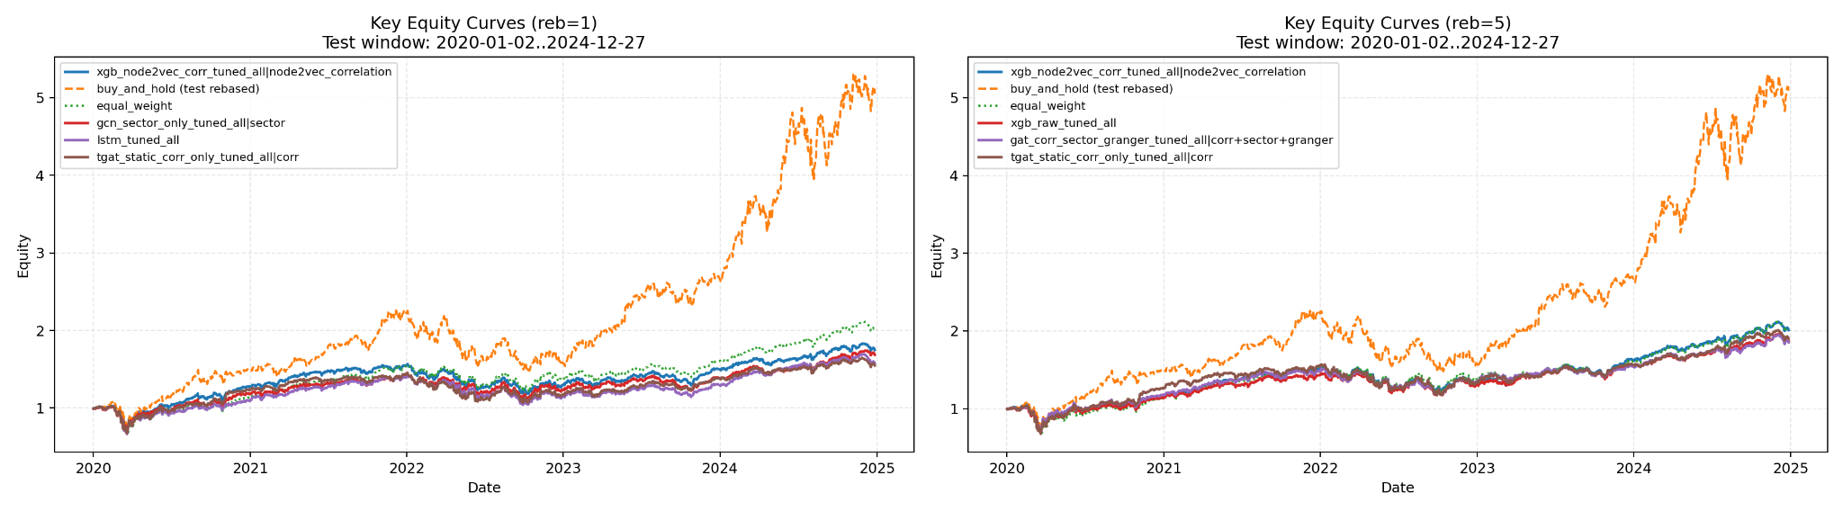

Figure A2. Risk frontier under reb=5: max drawdown versus annualized return.
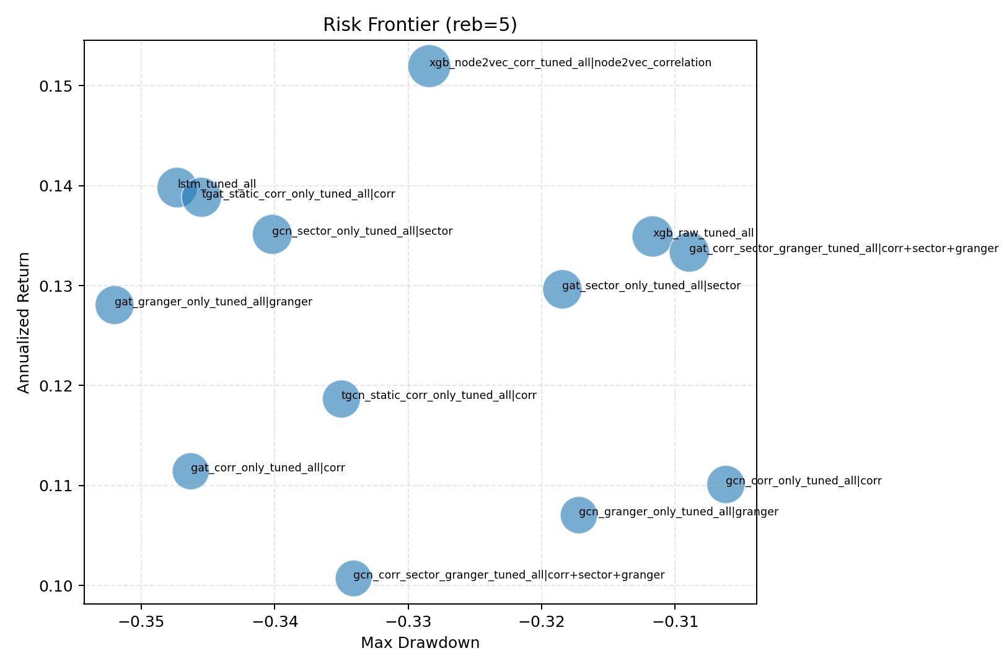

Figure A3. Mean Rank IC versus annualized Sharpe under reb=5.
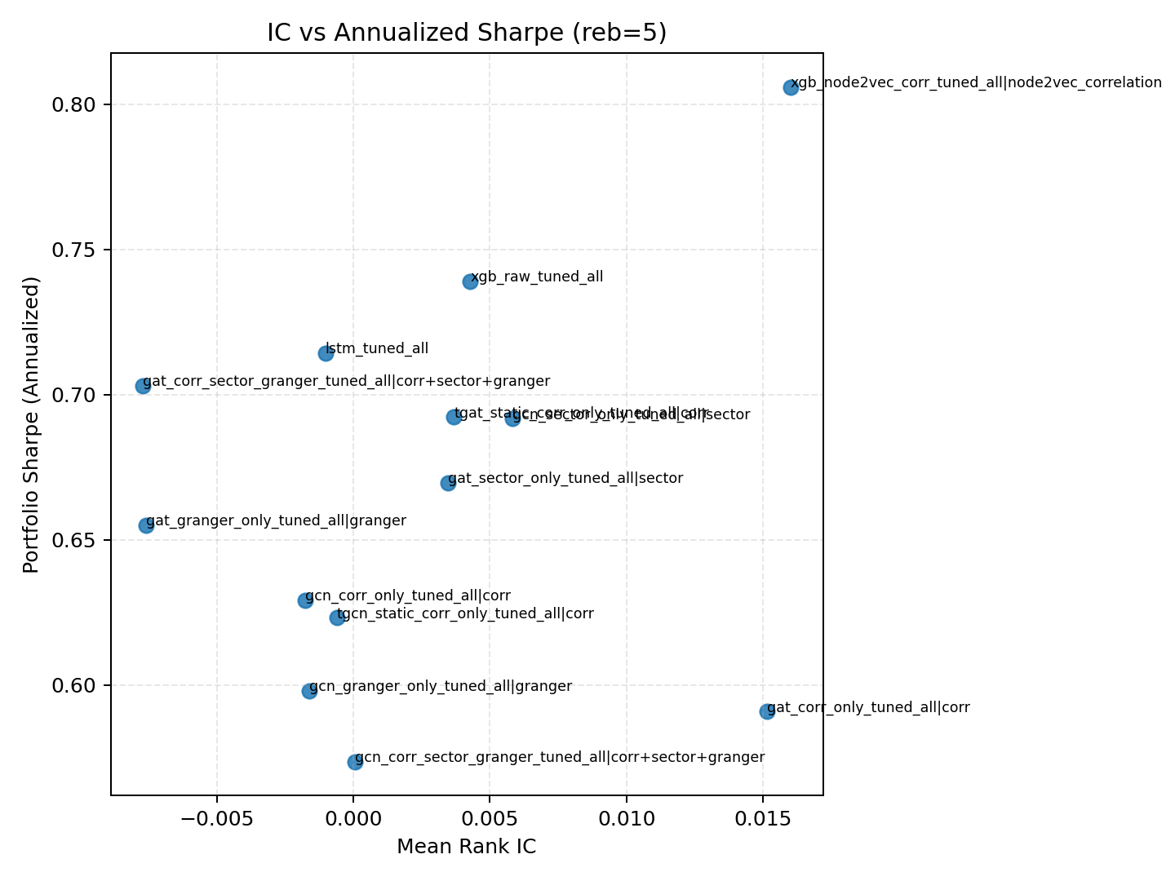

Figure A4. Daily Rank IC distribution under reb=5.
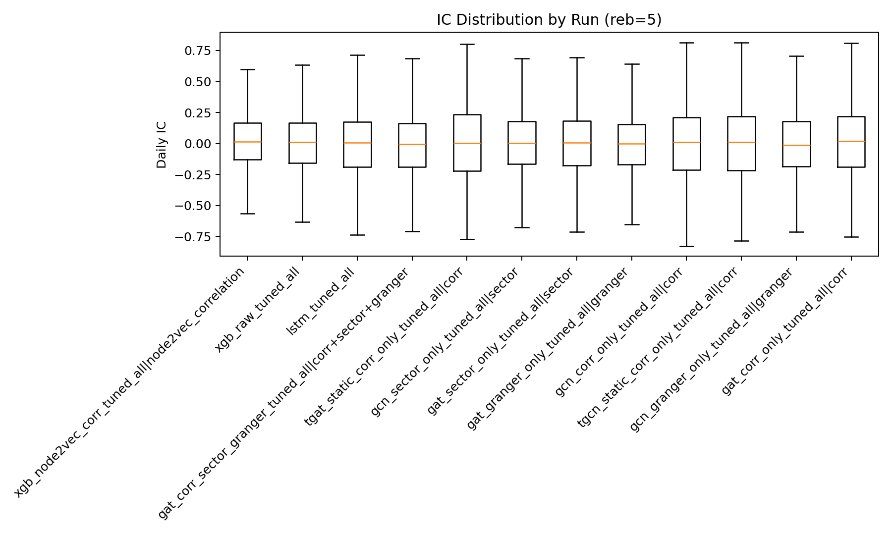

Figure A5. Mean Rank IC by run under reb=5.
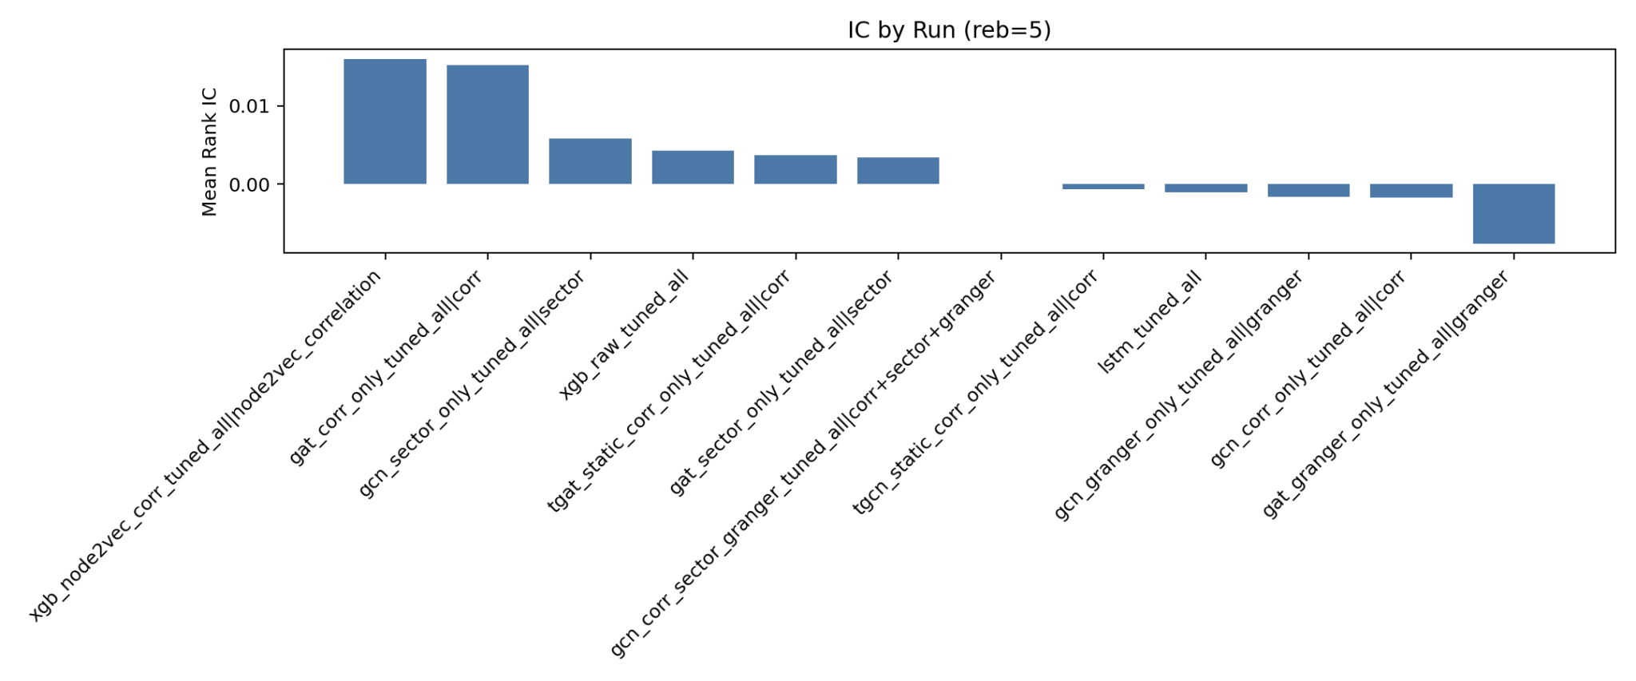

Figure A6. Portfolio metric bars under reb=5.
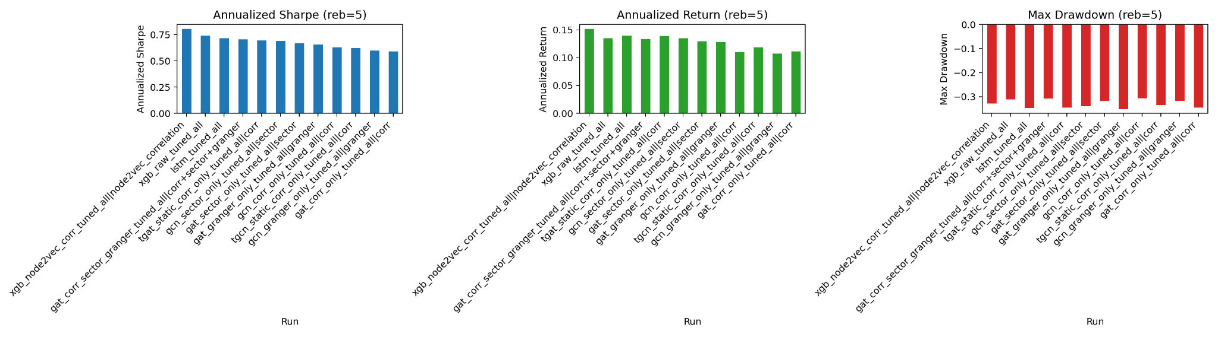

Figure A7. Risk frontier under reb=1: max drawdown versus annualized return.
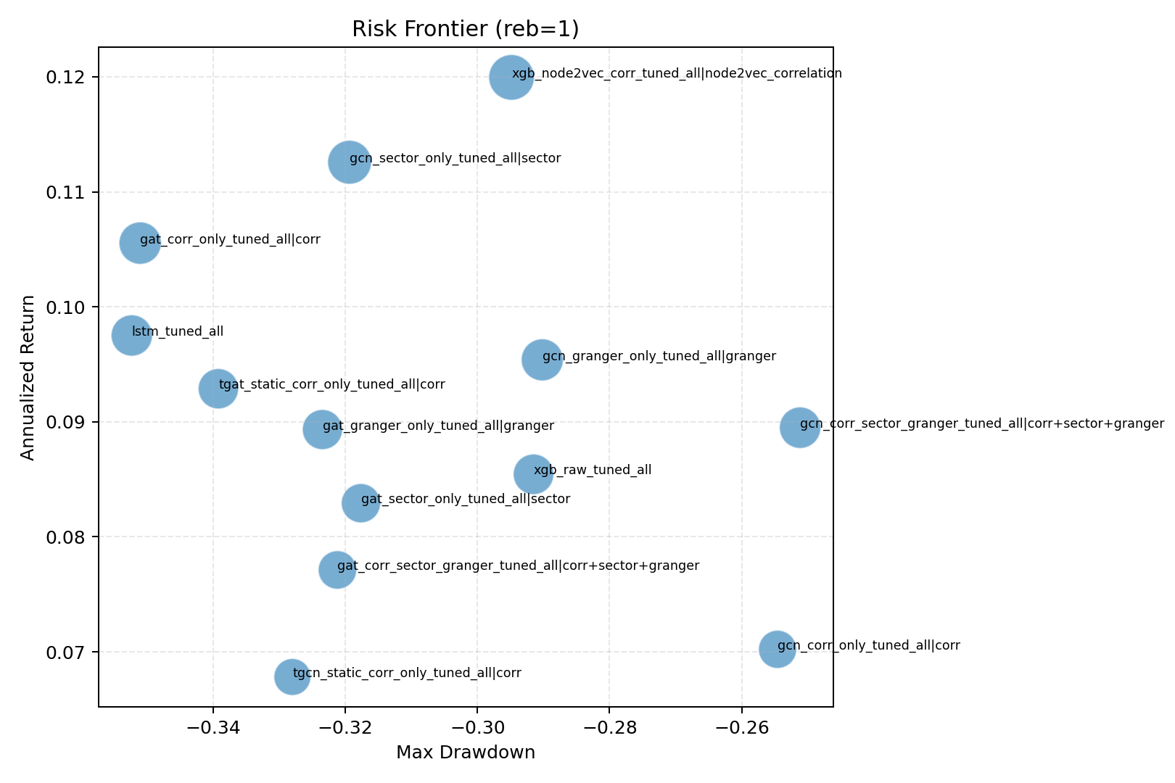

Figure A8. Mean Rank IC versus annualized Sharpe under reb=1.
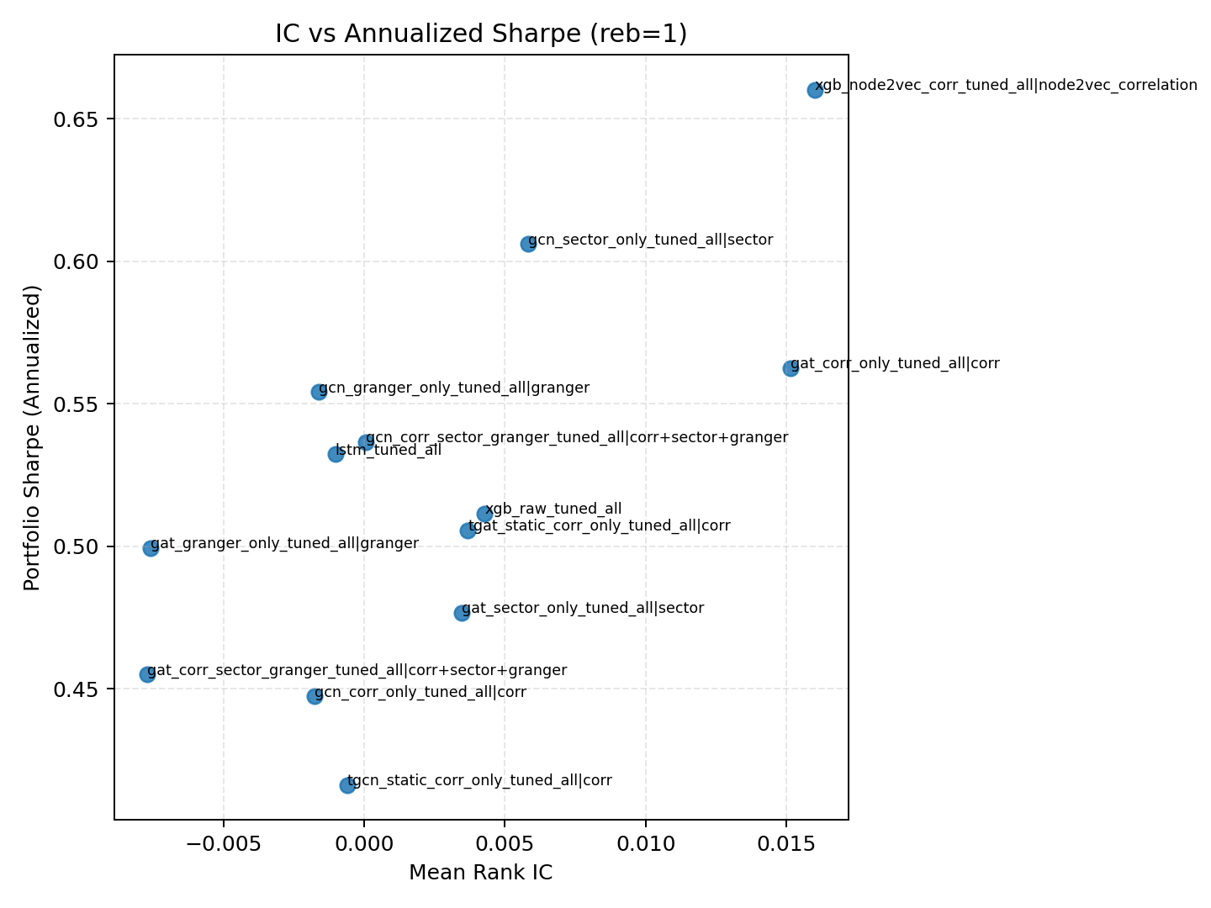

Figure A9. Daily Rank IC distribution under reb=1.
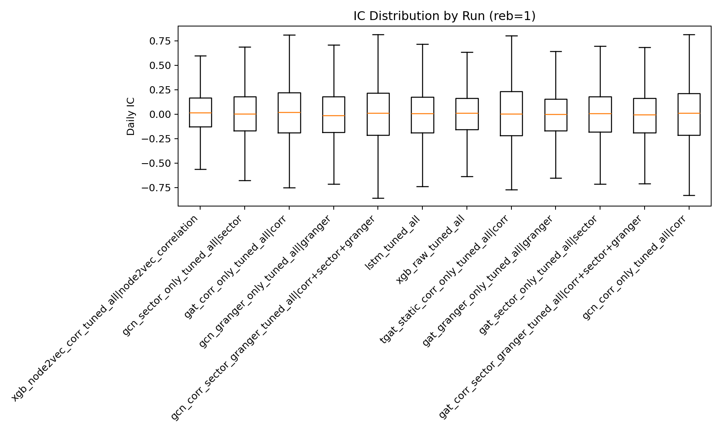

Figure A10. Mean Rank IC by run under reb=1.
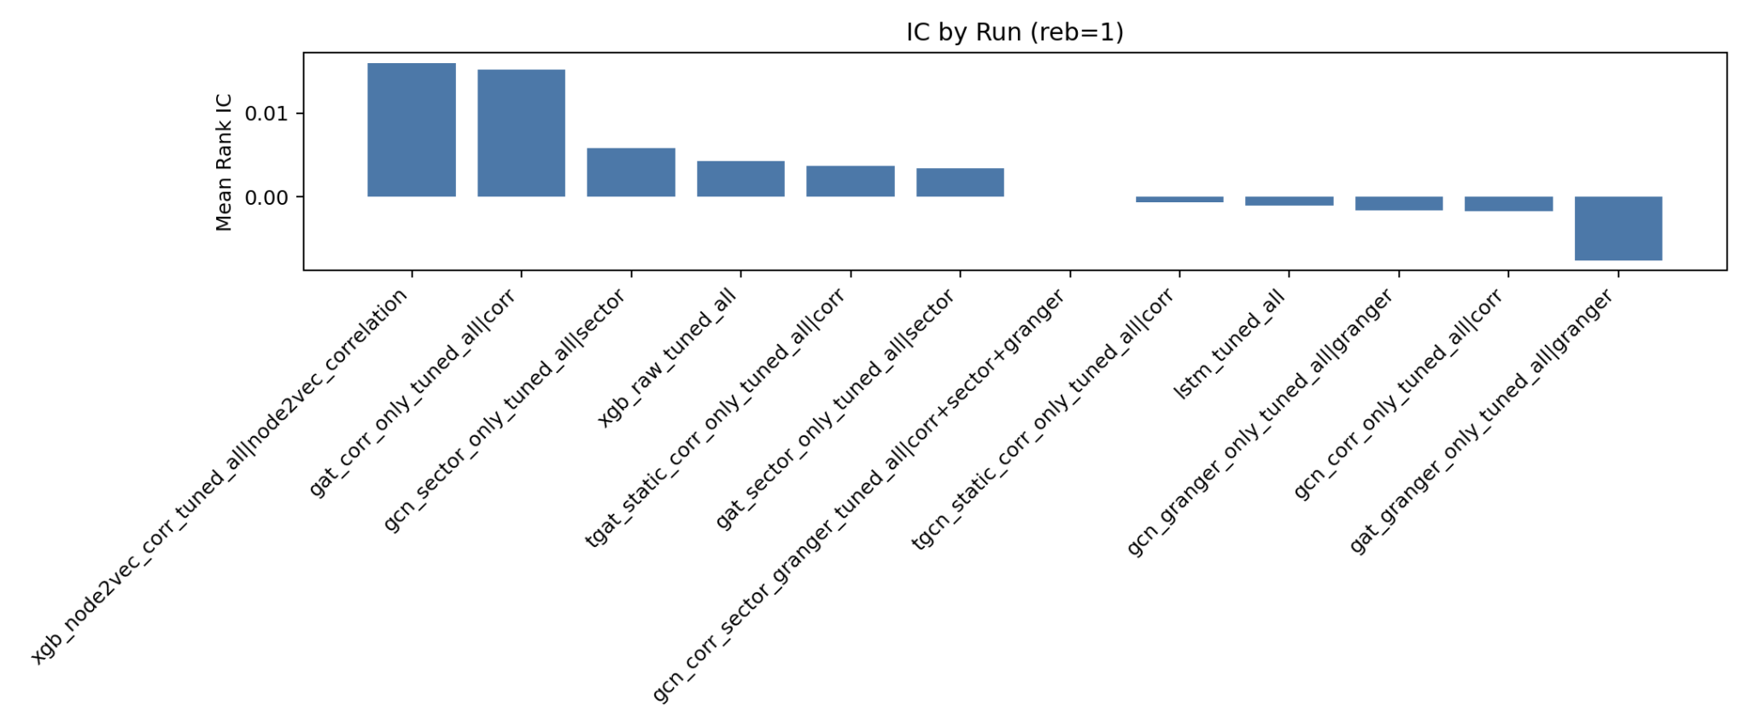

Figure A11. Portfolio metric bars under reb=1.
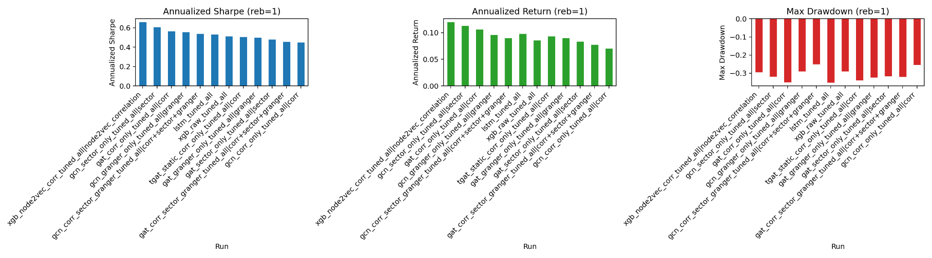

Update Addendum (2026-02-27): Latest Data and Graphs
Source artifacts: results/reports/thesis_tuned_all (refreshed on 2026-02-27).
- Naming policy: Buy and hold (fixed shares), Equal weight (rebalanced), Top K long only (equal weight within top K).
- Baseline metrics now reported with annualized Sharpe, annualized return, max drawdown, and final value in the same framework as models.

A) Baseline comparison (reb=1 and reb=5)
Strategy | Reb | Sharpe (ann.) | Ann Return | Max DD | Final
Buy and hold (fixed shares) | 1 | 1.2273 | 0.3842 | -0.3471 | 5.0493
Equal weight (rebalanced) | 1 | 0.7667 | 0.1519 | -0.3465 | 2.0222
Buy and hold (fixed shares) | 5 | 1.2273 | 0.3842 | -0.3471 | 5.0493
Equal weight (rebalanced) | 5 | 0.7667 | 0.1519 | -0.3465 | 2.0222

B) Weekly top runs plus baselines in one table (reb=5)
Strategy | Type | Sharpe (ann.) | Ann Return | Max DD | Final
xgb_node2vec_corr_tuned_all | Model | 0.8058 | 0.1519 | -0.3284 | 2.0112
xgb_raw_tuned_all | Model | 0.7390 | 0.1349 | -0.3117 | 1.8726
lstm_tuned_all | Model | 0.7143 | 0.1398 | -0.3473 | 1.9008
gat_corr_sector_granger_tuned_all | Model | 0.7030 | 0.1334 | -0.3089 | 1.8531
tgat_static_corr_only_tuned_all | Model | 0.6923 | 0.1388 | -0.3455 | 1.9014
gcn_sector_only_tuned_all | Model | 0.6916 | 0.1351 | -0.3402 | 1.8620
gat_sector_only_tuned_all | Model | 0.6696 | 0.1296 | -0.3184 | 1.8176
gat_granger_only_tuned_all | Model | 0.6550 | 0.1281 | -0.3520 | 1.8077
Buy and hold (fixed shares) | Baseline | 1.2273 | 0.3842 | -0.3471 | 5.0493
Equal weight (rebalanced) | Baseline | 0.7667 | 0.1519 | -0.3465 | 2.0222

C) Updated figures
equity curves key models reb5
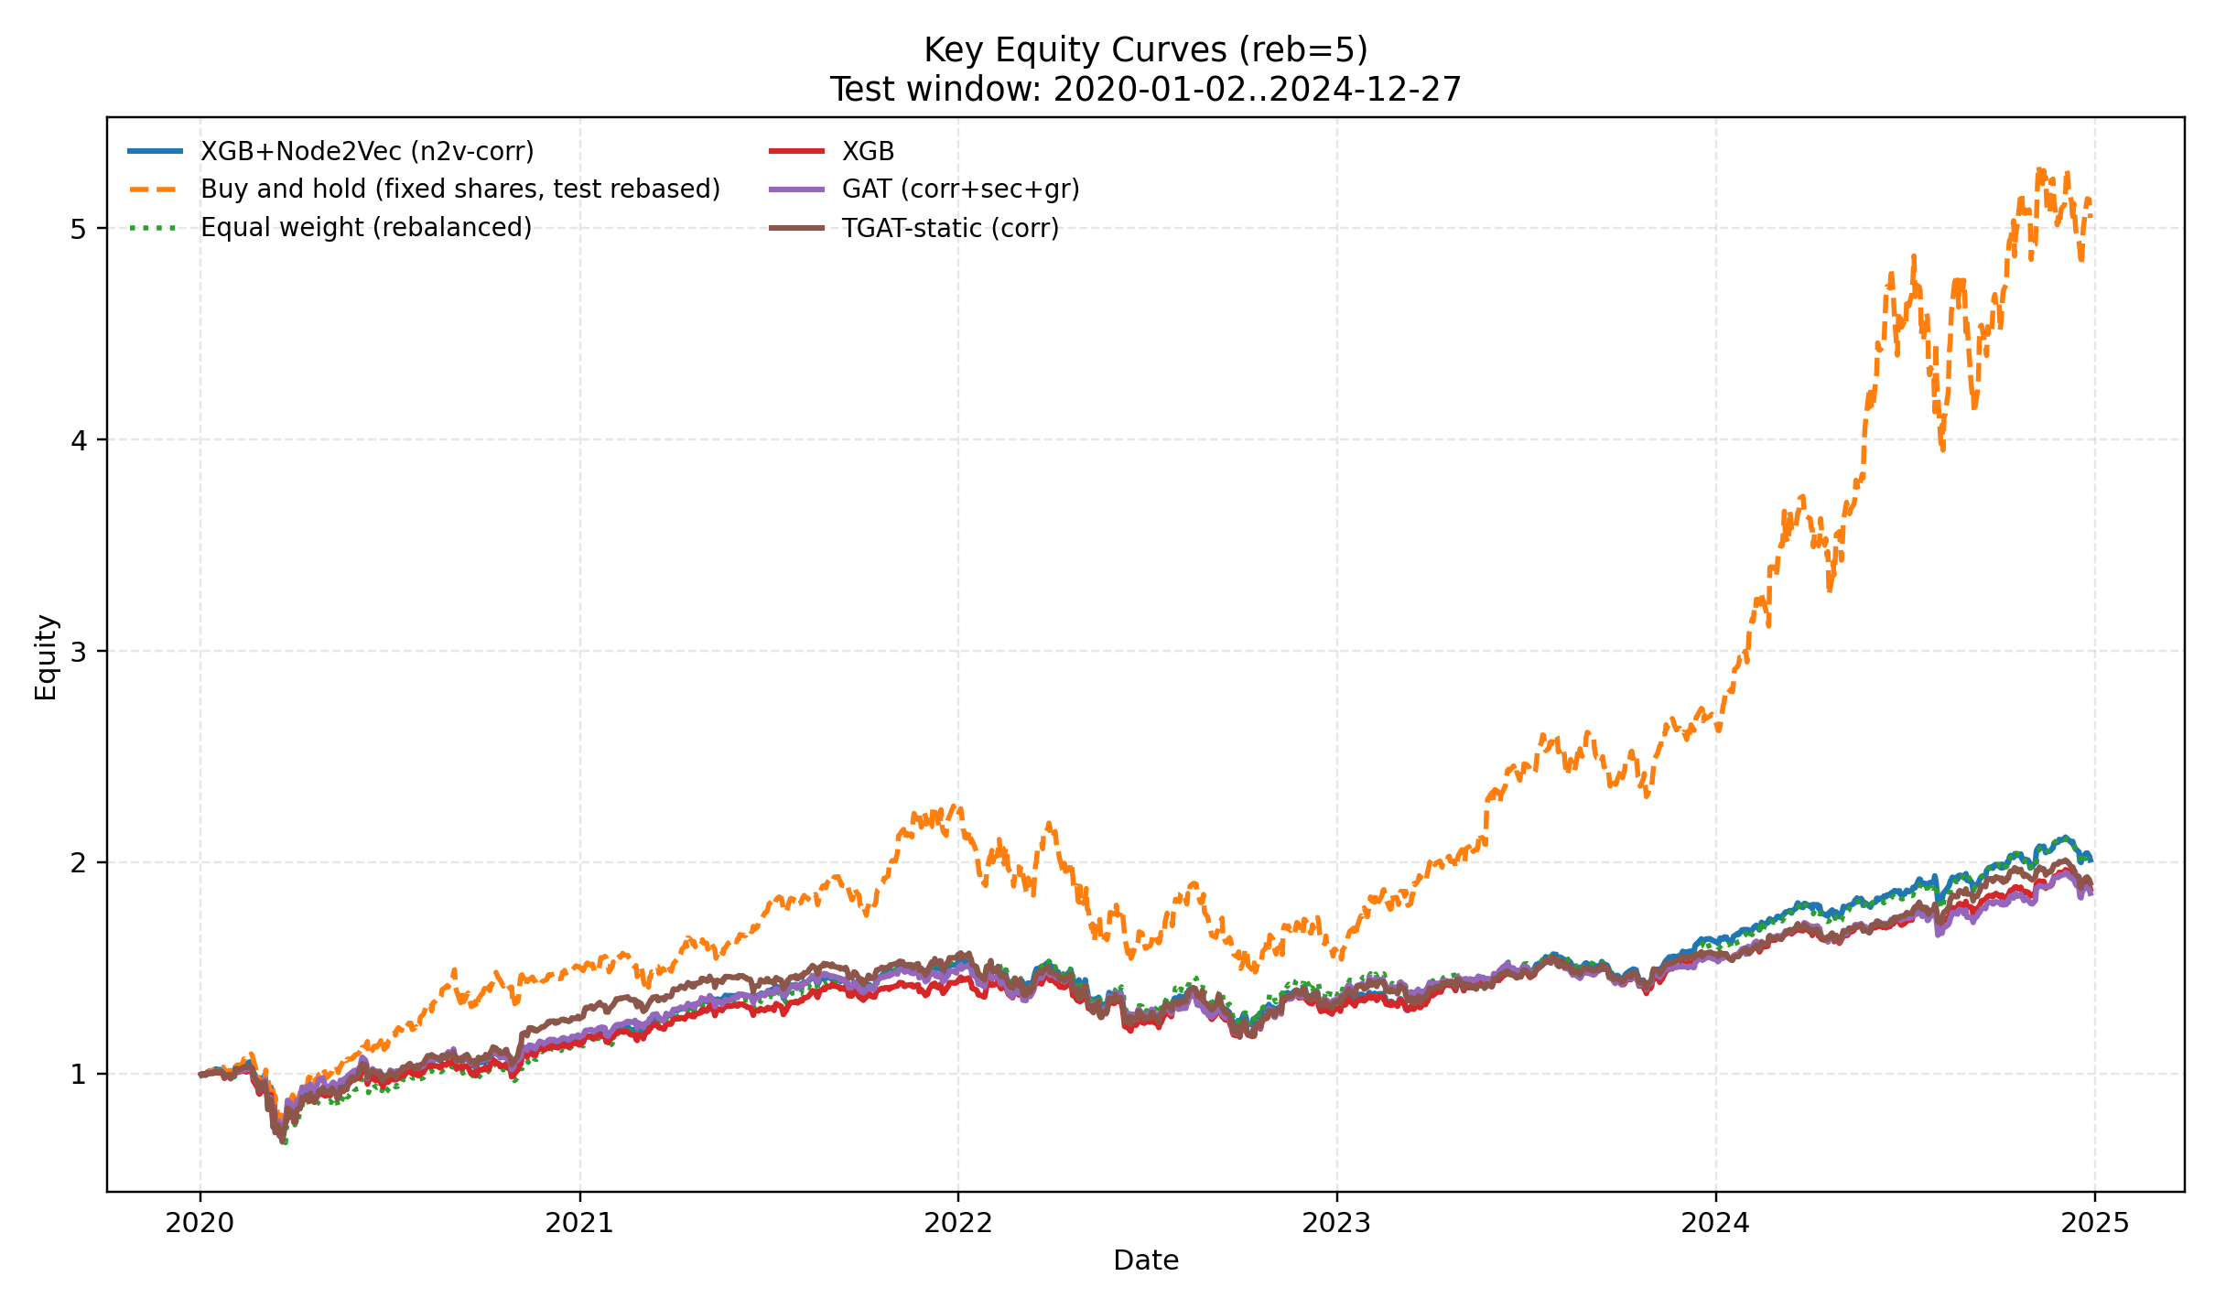

risk frontier reb5
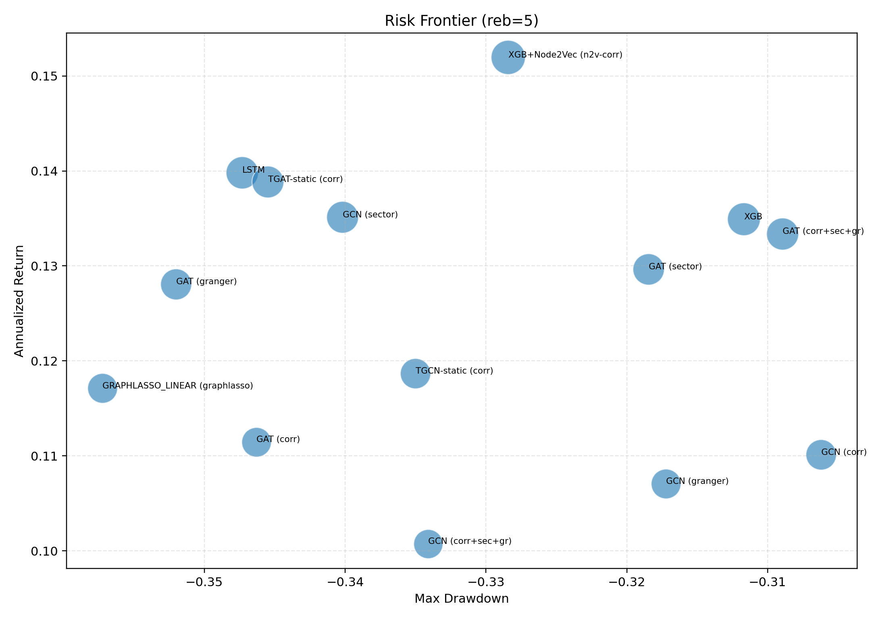

ic vs sharpe reb5
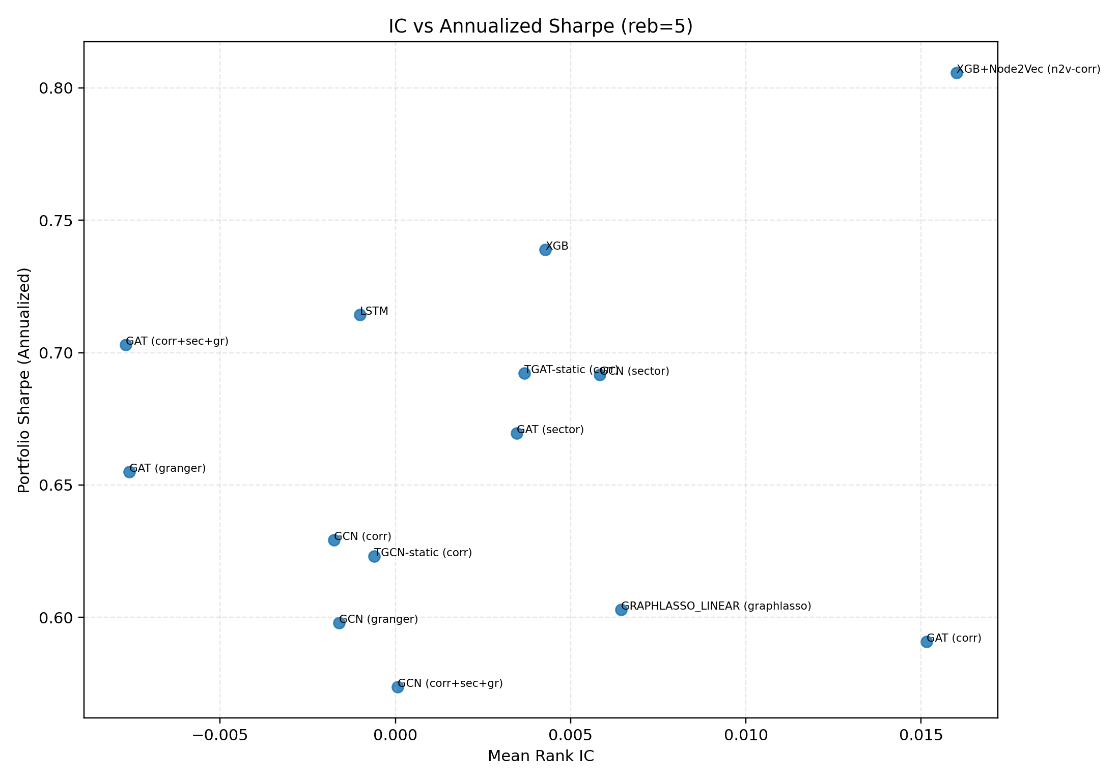

bar metrics reb5
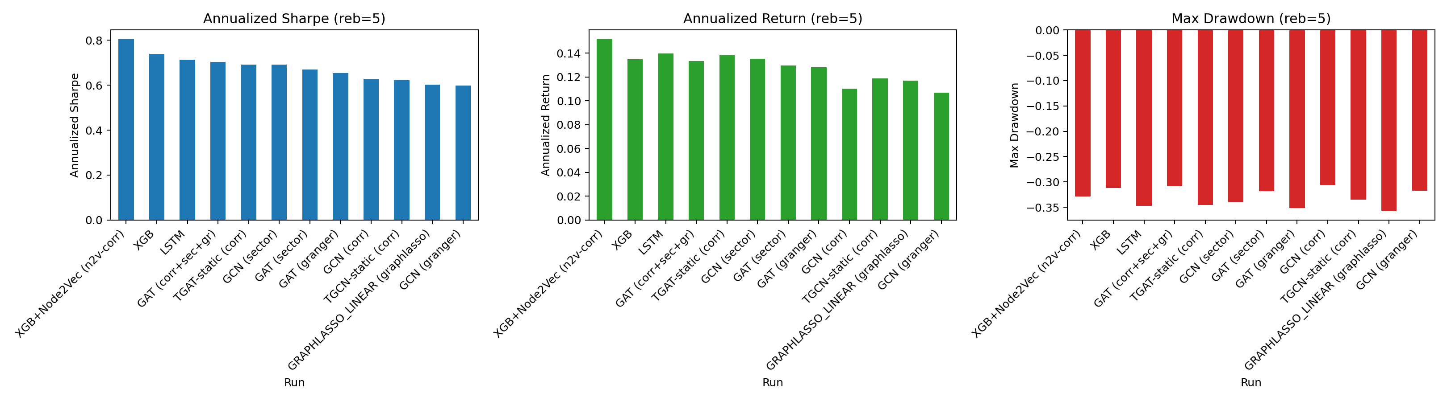

equity curves key models reb1
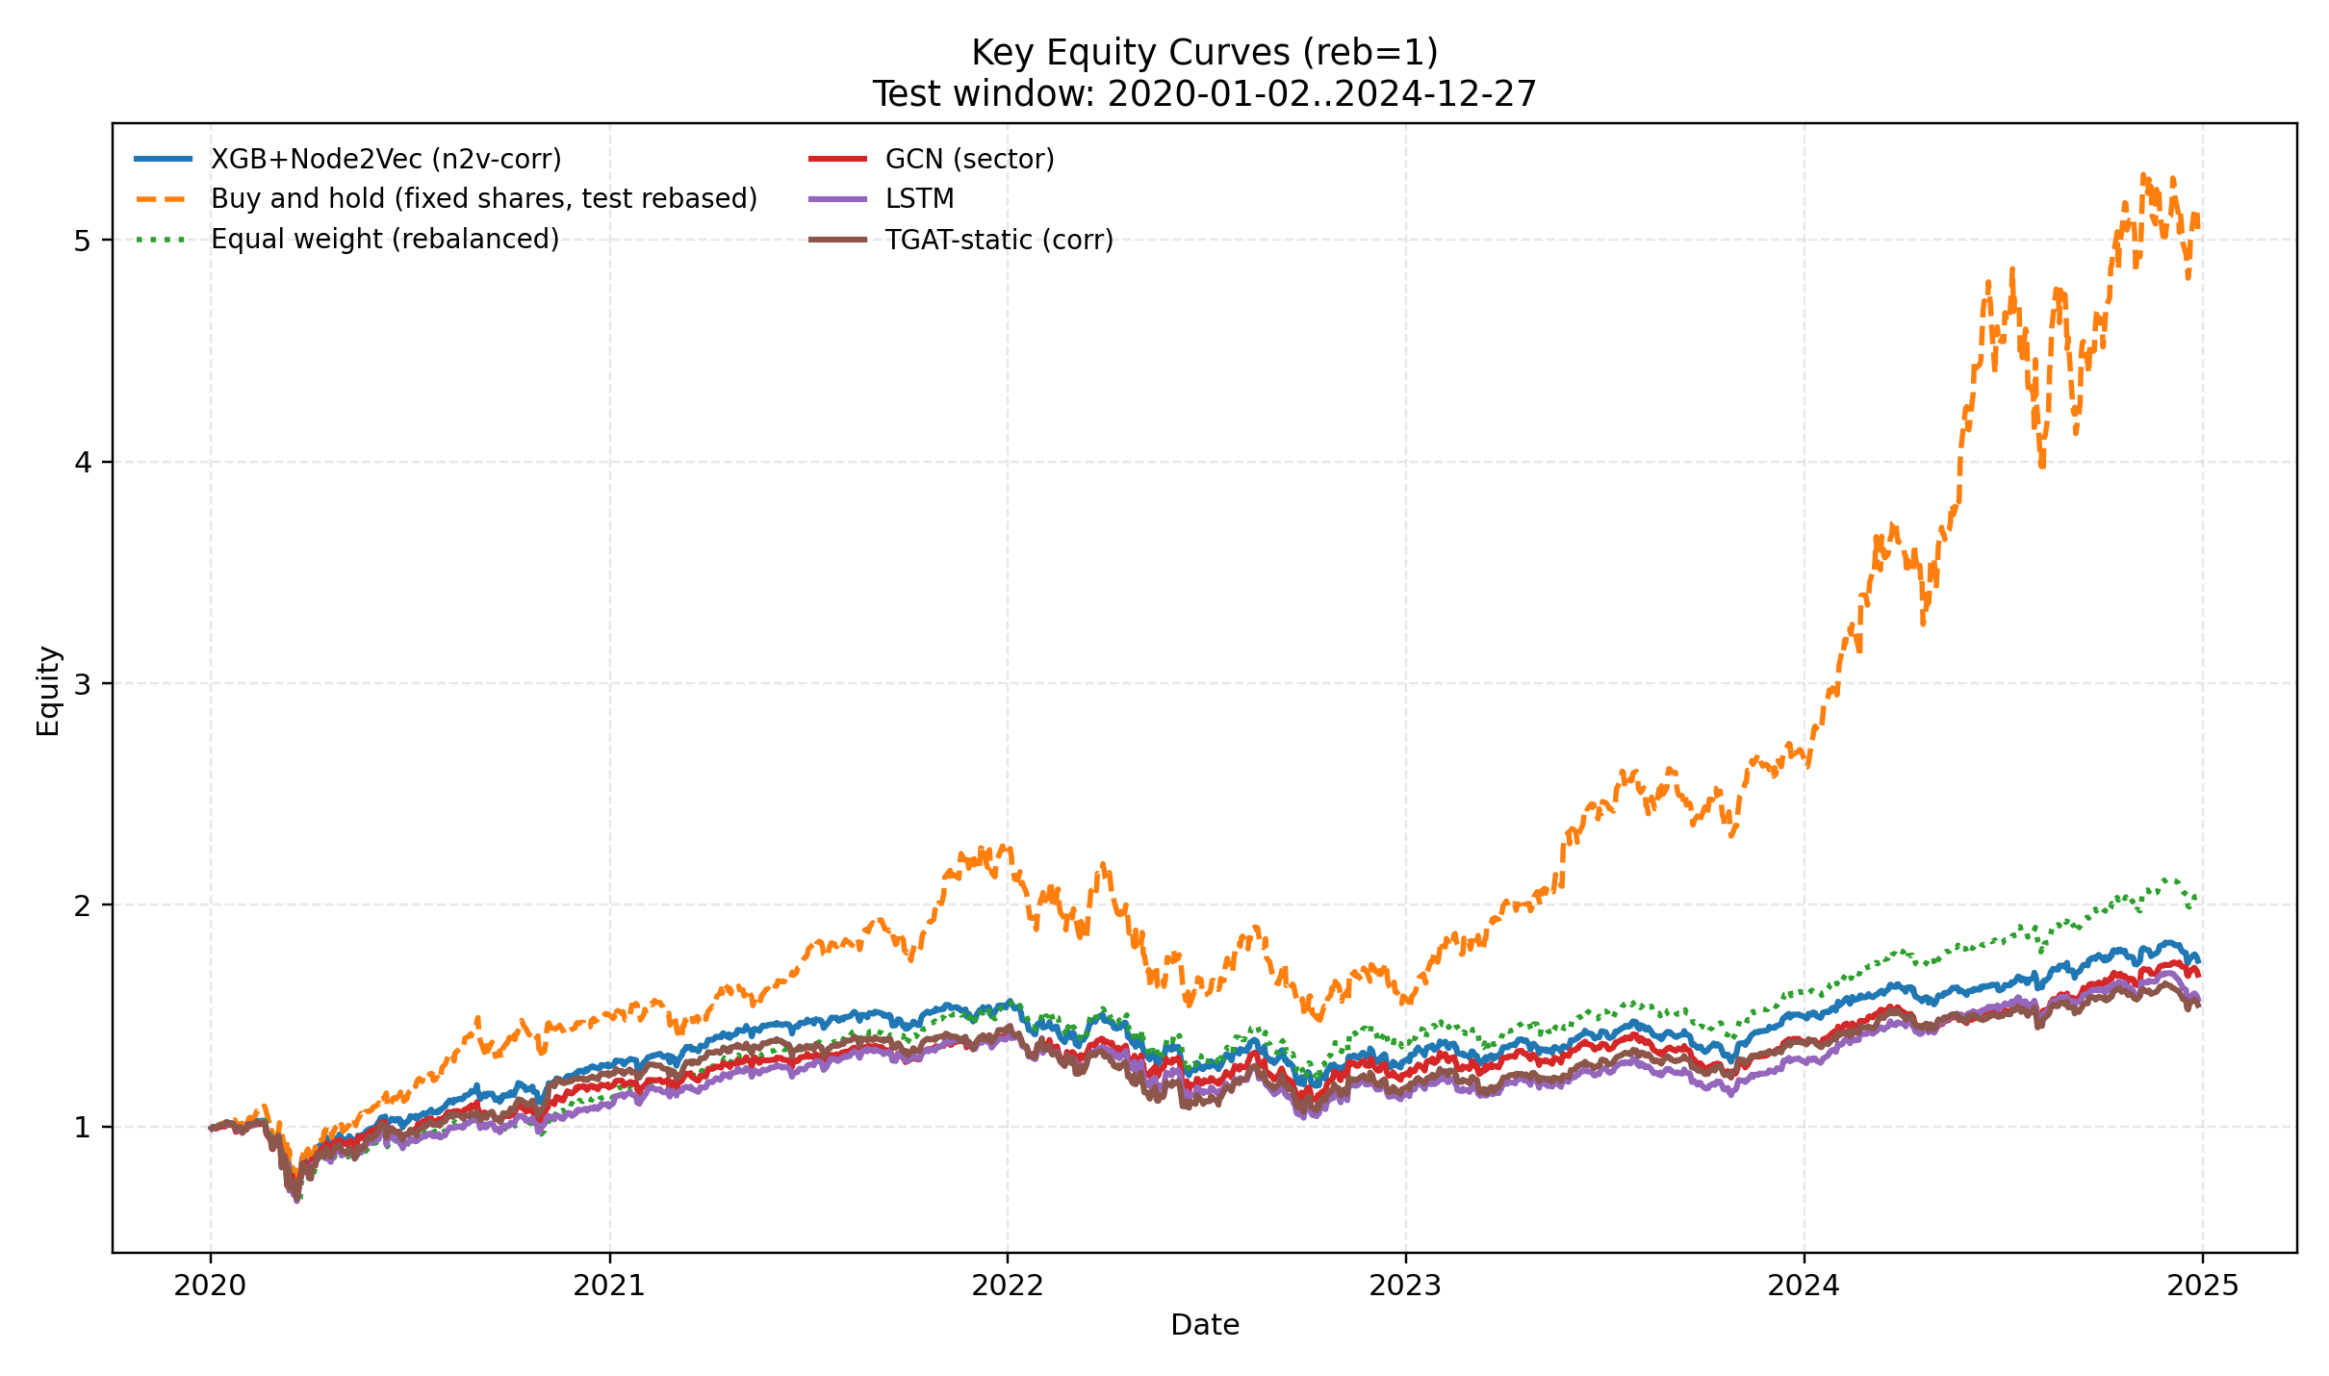

risk frontier reb1
